Project 1

The purpose of this assignment is to get familiar with HTML and CSS. The assignment will mainly be trying to replicate an existing static website. You will learn about HTML, CSS, git, responsive design, and Bootstrap in this project.

This course does not use any source of traditional grading or assessment. Instead, I will give you a performance review at the end of this week on how you did in the project (as if this was a real work environment).

There will be the following touch points on this project during the week:

* Monday - Part 1 (Project Setup) should be complete
* Wednesday - Part 2 should be complete
* Friday - Part 3 and 4 should be complete

On Friday (after 1 pm), everyone will have a 10 minute slot for their performance review.

# Part 1: Project Setup

The purpose of this part is to create your environment to code. The steps you need to follow are below:

1. Download a text editor
   1. To write CSS and HTML, you need to get a text editor that makes it easy. People have different preferences on text editors. I personally like [Sublime Text](https://www.sublimetext.com/), [Atom](https://atom.io/), or [Brackets](http://brackets.io/). You can see what others say about the best editors [here.](https://www.quora.com/What-is-the-best-editor-for-front-end-in-2017)
2. Create a folder for the project
3. Open the folder in your text editor
4. Create an ***index.html*** file, and write the basics for a webpage with the text “Hello World” in the body tag.
5. Open the file in Chrome and see it render in browser

# Part 2: Replicating a webpage

In this part, you will create an **index.html** file that replicates the following requirements of this website. You can create whatever external files (for example a css file) you want, as long as it works when you open the **index.html** file.

The goal is to try to make the website as identical to the requirements as possible. However, you are free to change the content to be personal.

Webpage Requirements:

1. The title of the page should be your first name .
2. The font of all headings (h1 - h6) should be Raleway. The font of all paragraphs should be Montserrat. The icons should be taken from [FontAwesome](https://fontawesome.com/).
3. The page should look like the screenshots below. Here is a [video](https://drive.google.com/open?id=1dV2ceqyxD0rr6DBeLjiJ3aZgXk6xqQLR) of the site.

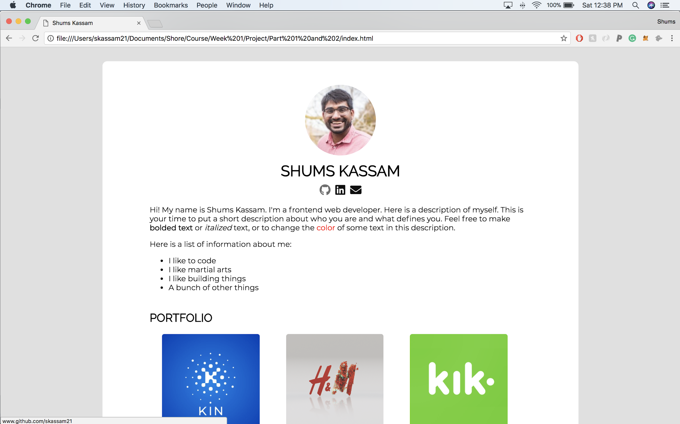

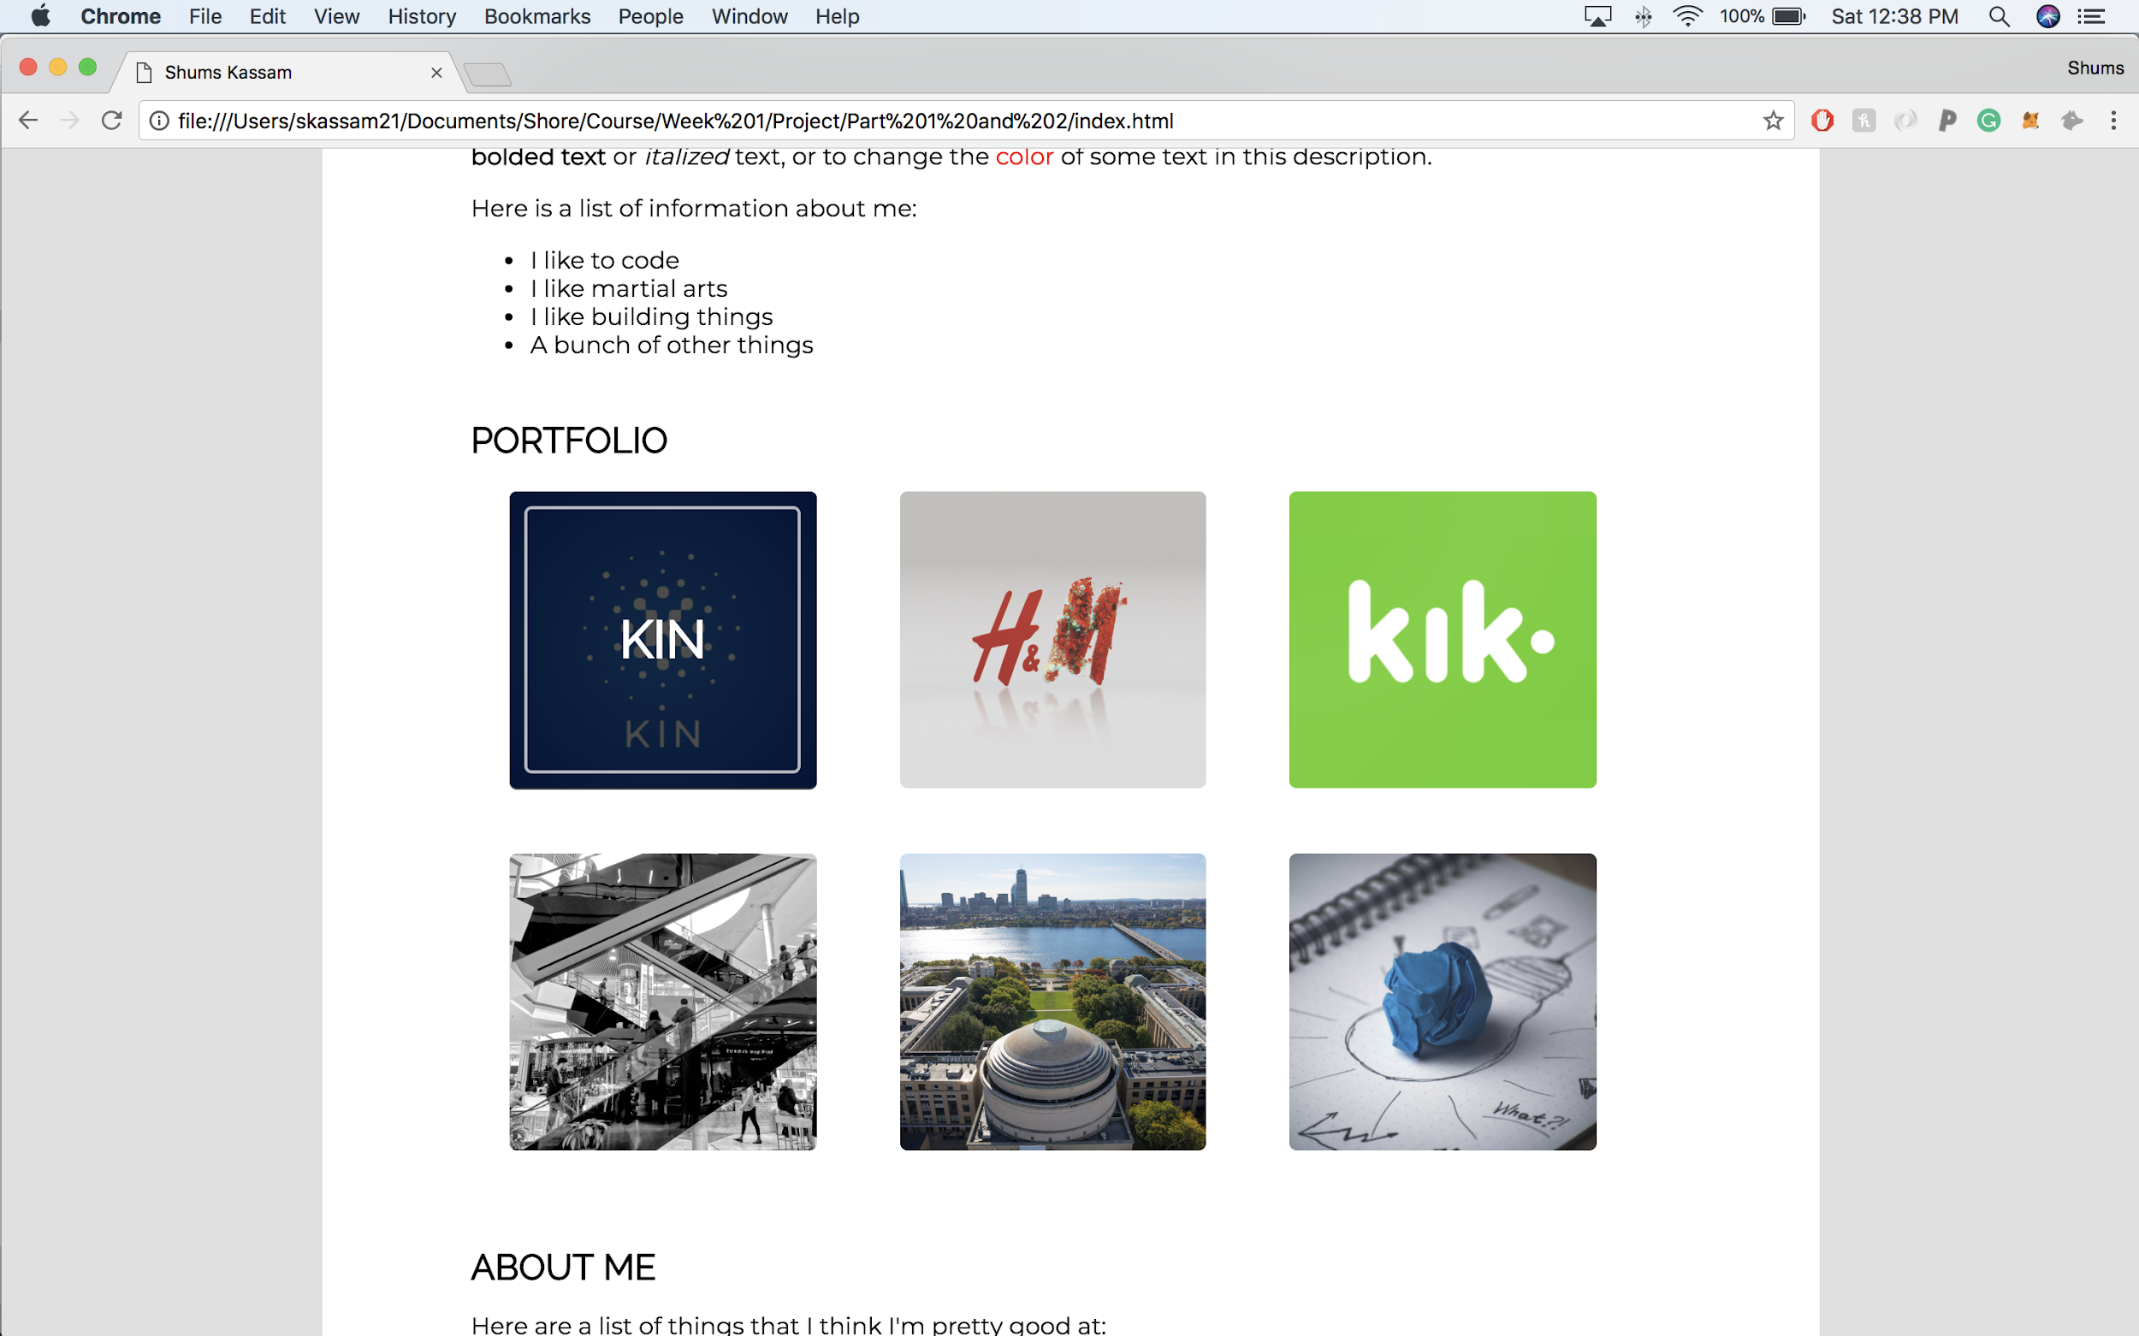

Notice what happens what you hover over the portfolio item with your mouse.

# 

# Part 3: Responsive Design

In this part, you will modify the webpage above to be “responsive”. You are allowed to use Bootstrap or any other responsive design framework (Foundation, W3.CSS, etc.). You can see a bunch of different responsive design frameworks [here](https://blog.templatetoaster.com/best-responsive-web-design-frameworks/).

You have more freedom to be creative here. You can reorganize, add, remove, and customize parts of your site from the previous part. Feel free to change the fonts and colors to fit your own personality. The main criteria for this site is that it is ‘responsive’. Make us of creating columns and having them resize when the screen size changes.

[This video](https://drive.google.com/open?id=1fKuikOp9zH2myXQ3QJVjPPjOomAZDtS3) is an example of responsive design.

# Part 4: Upload to Github

The last part of this project is to upload your project to github. In order to do that, you first to create a [github account.](http://github.com)

[This tutorial](https://product.hubspot.com/blog/git-and-github-tutorial-for-beginners) goes through github for beginners. Here is an [interactive tutorial](https://try.github.io/levels/1/challenges/1) for how to use github.